**Setting up AWS Security Hub in a test environment**

Setting up AWS Security Hub in a test environment using ***AWS Console****.*

* Login to AWS account

**Step 1:**Open the Security Hub Service page.

* After opening the security hub home page, click on “**Go to Security Hub**”.

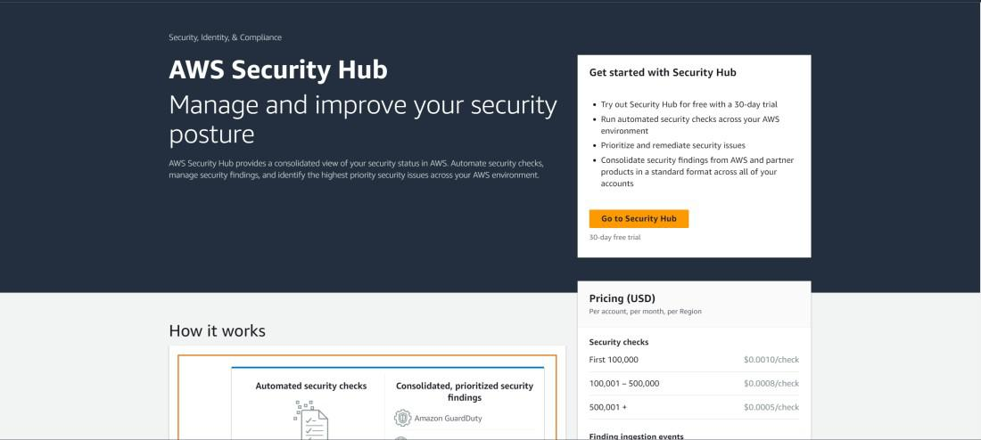

**Step 2:**Configure Security Hub Options.

* Choose Security standards based on which security checks will be performed, and then click on “**Enable Security Hub**”.

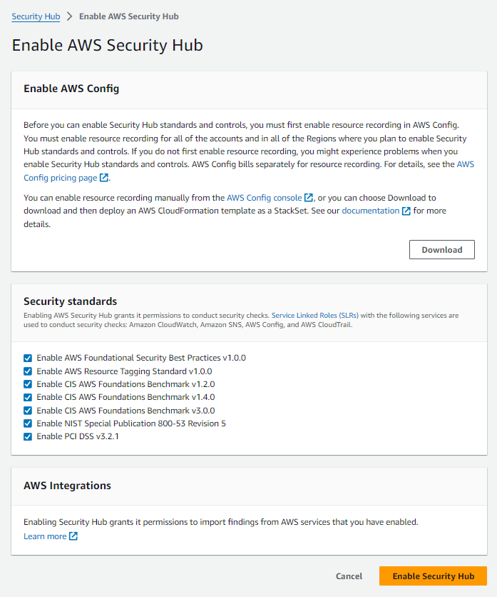

**Step 3:**View Findings.

* After enabling the security hub, it may take some time for Security Hub to collect and analyze data before presenting findings and then you can view issues in the **Findings**Tab.

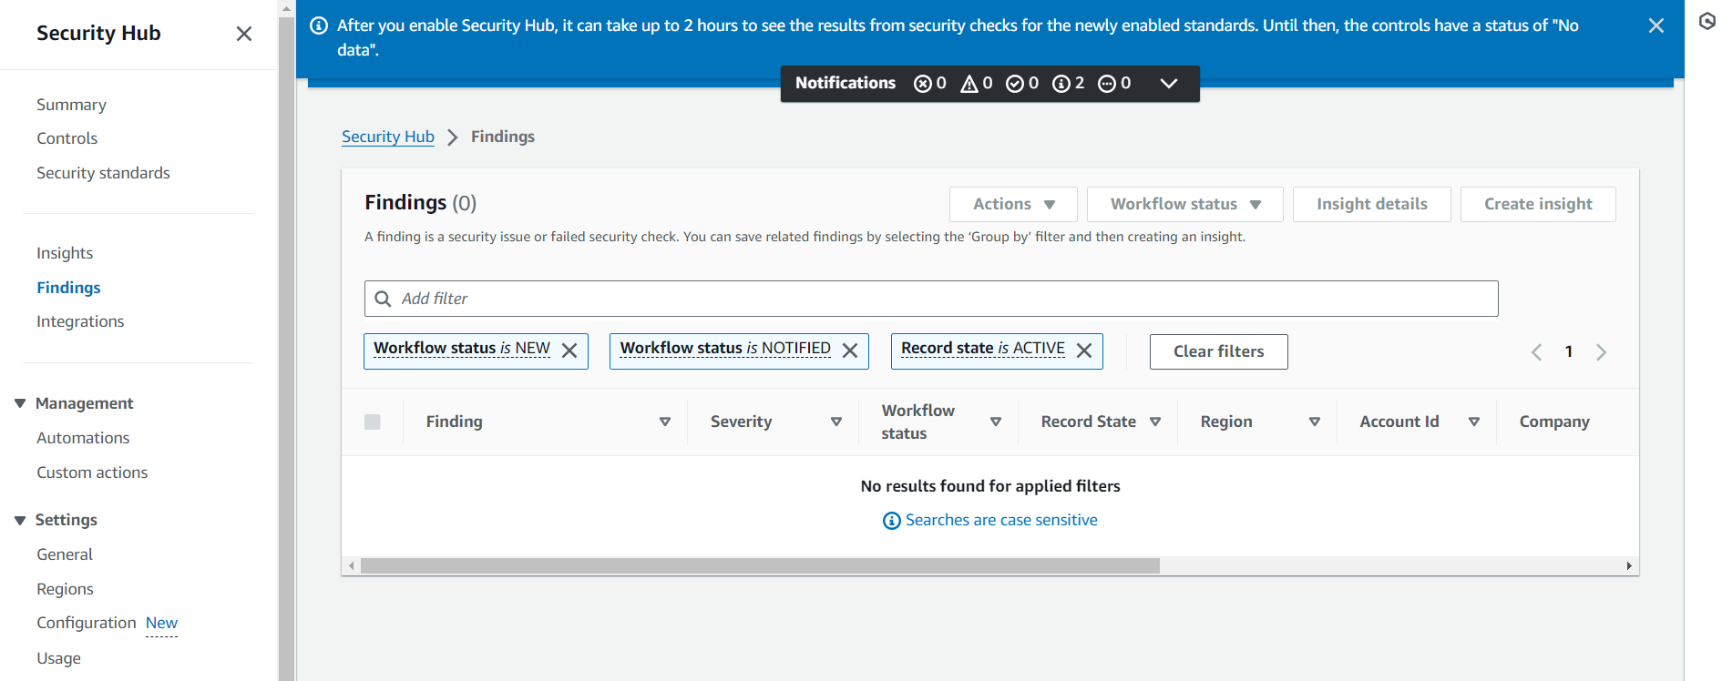

*For more detailed information on AWS Security Hub and its setup refer to the following link:* [*https://www.geeksforgeeks.org/how-to-set-up-aws-security-hub/*](https://www.geeksforgeeks.org/how-to-set-up-aws-security-hub/)